For the Pymaceuticals activity there were a total of 3 observations that should be pointed out. Both Ramicane and Capomulin had the lowest SEM values, and therefore it means the samples had the least variation out of the drugs analyzed. These drug regimens also had the highest mice studied out of the 10 regimens, which would help reduce the variation with a larger sample size. These regimens also had the lowest mean and median, below the starting value, and all other drugs did not decrease the tumor volume (mm3).

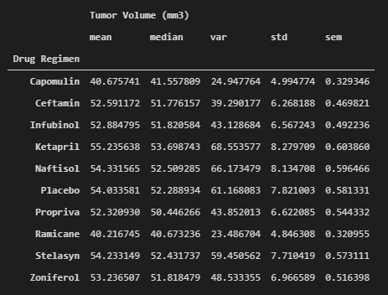

For Capomulin the attached chart is for mouse “m601”, it shows that the tumor volume decreased over time, and was the largest decrease of all samples.   
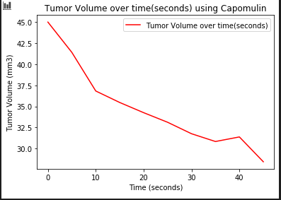

Based on all available evidence and analysis Capomulin and Ramicane are the only drugs out of the 10 regimens that reduce the tumor size.